Pre lab 1

Part 1:

No spectral leakage

N and Ncyc are coprime and the ratio isn’t integer

Ncyc must be more than 2 for no leakage

We will have sharp peak at fin ​ and negligible energy in other frequencies.

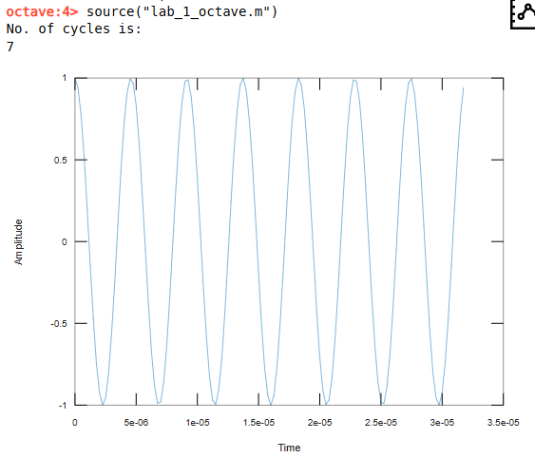

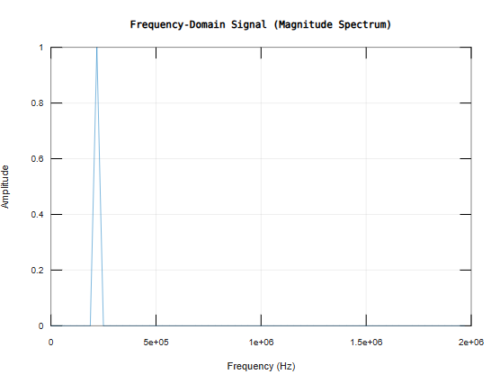

Part 2:

Adding 0.5 makes Ncyc non-integer, violating coherence conditions.

Now the energy spreads on other frequencies which leags to spectral leakage .

